## Question 5: Survival analysis using Kaplan-Meier method

The overall Kaplan-Meier curve provides a visual representation of the customer retention rate over time.

The plot shows the estimated probability of a customer *not* churning over time (tenure in months).

* **Starting Point:** The curve starts at a survival probability of 1.0 (or 100%) at time 0, which makes sense because all customers have "survived" (not churned) at the very beginning.
* **Downward Trend:** As tenure increases (moving along the x-axis), the survival probability decreases. This indicates that over time, more and more customers are churning.
* **Steepness of the Curve:** The rate at which the curve drops reflects the churn rate. A steeper drop means a higher churn rate during that period. Initially, the curve drops rapidly, suggesting a higher churn rate in the early months of a customer's tenure which is quite common in Telecom due to early churn. The curve becomes less steep as tenure increases, indicating that customers who stay longer are less likely to churn.
* **Survival Probability at Specific Times:**  We can look at any point on the x-axis (tenure) and see the corresponding survival probability on the y-axis, For example, you can estimate the probability that a customer will stay for at least 10 months, 20 months, and so on

**Plot** :

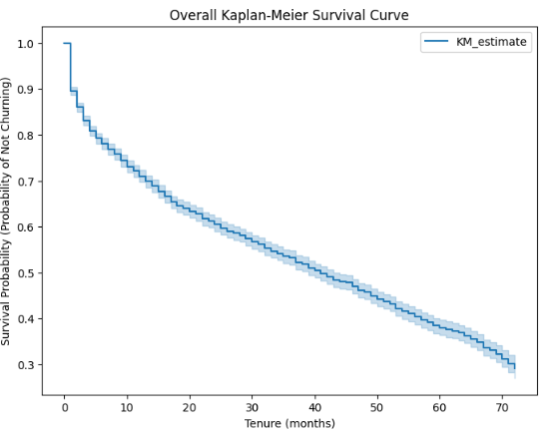

*It clearly shows that churn occurs throughout the customer lifecycle, with a higher likelihood of churn in the earlier stages*

## Question 6: Separate Survival Curves for different Categories

## a) Survival Curves by Gender

* The male survival curve is consistently above the female curve, indicating males have a lower churn risk (higher survival probability) at most tenure. For example, at 12 months, 69% of males remain vs. 58% of females—a ~11% difference
* Females show a steeper early decline (higher initial churn), possibly due to sample-specific factors like service dissatisfaction

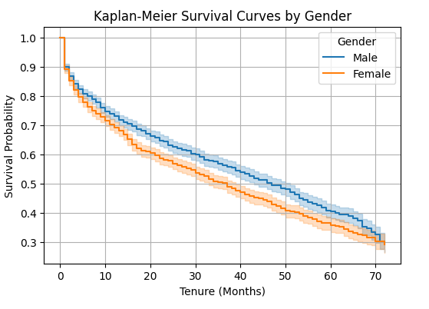

## b) Survival Curves by Contract Type

* **Month-to-month contracts:** Customers with month-to-month contracts have the lowest survival probability, meaning they are much more likely to churn relatively quickly compared to customers with longer-term contracts. The curve drops steeply, especially in the early months.
* **One year contracts:** Customers with one-year contracts have a higher survival probability than those with month-to-month contracts. Their curve is above the month-to-month curve, indicating a lower churn rate over time.
* **Two year contracts:** Customers with two-year contracts have the highest survival probability. Their curve stays significantly above the other two curves, showing that customers on two-year contracts are the least likely to churn and tend to stay with the service for much longer.

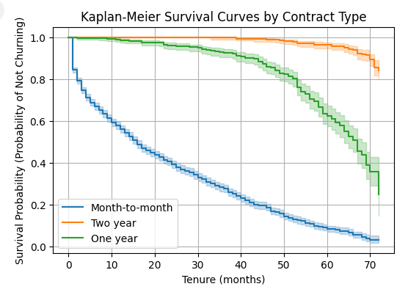

*This suggests that the contract type is a very strong predictor of customer churn, with longer contract terms being associated with much lower churn rates*

## c) Survival Curves by Senior Citizen status

* The survival curve for Non-Senior Citizens is consistently above the curve for Senior Citizens (
* This indicates that Non-Senior Citizens generally have a higher survival probability and are less likely to churn compared to Senior Citizens over the same period of time.

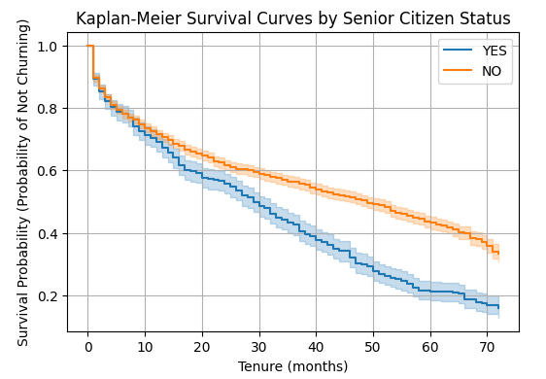

## d) Survival Curves by Partner status

* The survival curve for customers with a Partner is significantly higher than the curve for customers without a Partner.
* This suggests that customers who have a partner are less likely to churn and tend to stay with the service for a longer duration compared to customers who do not have a partner.

